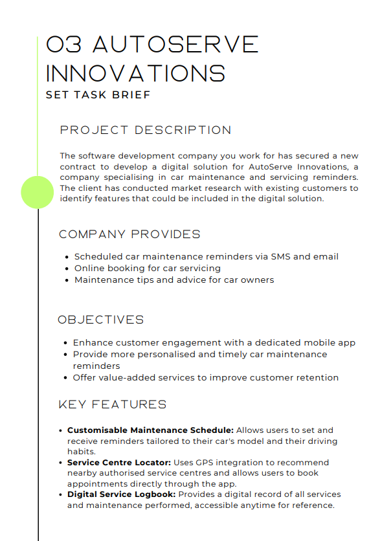

Proposal for AutoServe Innovations

1. Project Overview
AutoServe Innovations aims to modernise how customers manage their car maintenance by introducing a dedicated digital platform. The goal is to make maintaining a vehicle easier, more convenient, and more reliable by offering personalised reminders, service-booking tools, and practical maintenance guidance. The upgraded system will boost customer engagement, improve service efficiency, and strengthen long-term customer loyalty.
In addition, AutoServe Innovations plans to expand its services through a dedicated mobile app, giving users a unified space to receive reminders, book servicing, and access trusted maintenance advice.
- The proposed digital solution will include:
Customisable Maintenance Schedule
Allows users to set and receive reminders tailored to their car model and driving habits.
- Service Centre Locator
Uses GPS integration to recommend nearby authorised service centres and allows users to book appointments directly.
- Digital Service Logbook
Provides a secure record of all services and maintenance carried out on the user’s vehicle.
These features directly support AutoServe’s mission of improving customer engagement and making vehicle maintenance simpler and more personalised.

2. Problems Identified
Problem 1 – Lack of Personalised Maintenance Support
Current reminders are general and not adapted to individual vehicle models or driving styles, making it harder for users to maintain their cars efficiently.
Problem 2 – Inconvenient Booking and Service Centre Access
Users struggle to quickly find trusted service centres or book appointments in one place, leading to frustration and reduced engagement.
Problem 3 – No Centralised Record of Maintenance History
Customers currently have no digitalised space to view their service history, making it difficult to track past work or share information with mechanics.

3. Proposed Solutions
Solution to Problem 1 – Customisable Maintenance Schedule
A system that sends personalised reminders based on car model, mileage, and driving habits, helping users stay on top of necessary maintenance.
Solution to Problem 2 – Service Centre Locator
A GPS-powered tool allowing users to find reputable service centres, view availability, and instantly book appointments.
Solution to Problem 3 – Digital Service Logbook
A secure digital logbook automatically updated after each service, helping users track their maintenance history easily.

4. Decomposition of Solutions
Customisable Maintenance Schedule
The schedule tool collects details such as vehicle model, mileage, last service date, and typical driving patterns. The system then generates tailored reminders for oil changes, MOT checks, tyre rotations, and other key tasks.
Users receive notifications via the app, SMS, or email, ensuring they never miss essential servicing. They can update car details at any time to keep reminders accurate.
Service Centre Locator
The locator uses GPS to identify nearby authorised service centres. Users can view availability, compare distances, and book appointments quickly.
Extra features, such as opening hours, ratings, and contact details, ensure users choose the best location. The built-in booking confirmation updates instantly inside the app.
Digital Service Logbook
The logbook stores all past service records in one place, including dates, tasks completed, and any mechanic notes.
Users can access this information anytime, and it is especially helpful when selling a vehicle or diagnosing recurring issues. The layout is mobile-friendly and fully accessible.

5. Client and User Needs
AutoServe’s main goals are to improve customer engagement, provide personalised maintenance reminders, and offer helpful tools that make vehicle care effortless.
• New car owners need simple explanations and clear instructions.
• Busy drivers need fast loading times and quick access to reminders and service booking.
• Users with disabilities need screen reader compatibility, strong contrast, and accessible navigation.
• Long-term drivers benefit from an easy way to track maintenance history.
To meet these needs, the system should include personalised reminder tools, a simple booking system, a Digital Service Logbook, and an accessible interface. These features will increase convenience, improve customer retention, and build trust.

6. Mitigating Potential Risks
Customisable Maintenance Schedule
Validation checks will prevent incorrect car data being entered. The reminder engine will undergo routine automated testing to ensure accuracy.
User Accounts
Accounts will use encrypted passwords, MFA, and secure password resets. Alerts will notify users of unusual login activity.
Service Centre Locator
Incorrect GPS data will be reduced using reliable mapping APIs and automated error-checking. Spam bookings will be limited with captcha and authenticated accounts.
Digital Service Logbook
All service data will be verified before being stored. Encrypted backups and regular checks will prevent loss or corruption of information.
Technical Reliability
Cloud hosting, load balancing, autoscaling, and disaster-recovery protocols reduce downtime and ensure stable performance.

7. Security & Compliance Risks
Security Features
All personal and vehicle data will be encrypted during storage and transfer. MFA and RBAC will ensure only authorised users and staff can access sensitive information.
Regular audits will detect vulnerabilities early.
The platform will meet WCAG accessibility guidelines and follow GDPR for secure, lawful handling of user data.
Legal Requirements
• Equality Act 2010 – requires accessibility for disabled users.
• Consumer Rights Act 2015 – ensures advice given is accurate and not misleading.
• GDPR – mandates lawful, secure handling of personal data.
• Copyright laws – apply to third-party maintenance guides and images.

8. System Requirements
Functional Requirements
- Secure user login with account management
- Customisable Maintenance Schedule with tailored reminders
- GPS-powered Service Centre Locator with booking
- Digital Service Logbook for tracking maintenance history
- Notifications via SMS, email, and in-app alerts
Non-Functional Requirements
- 99.9% uptime
- Strong data security and encryption
- Fast loading times, even at peak usage
- Scalable infrastructure
- Full WCAG accessibility compliance

9. Key Performance Indicators (KPIs)
- Reminder Accuracy: 90% accuracy in tailored maintenance reminders within four months
- User Engagement: 30% increase in active users within six months
- Booking Activity: 20% growth in service bookings made through the platform
- Page Load Time: Under 2.5 seconds for all major pages
- System Uptime: 99.9% availability
- User Retention: 15% retention boost within six months

10. User Acceptance Criteria (UAC)
Customisable Maintenance Schedule
Must generate correct, timely reminders and allow users to update vehicle details easily.
Service Centre Locator
Users must be able to locate centres quickly, book smoothly, and receive confirmation with no errors.
Digital Service Logbook
The logbook must load fast, show accurate records, and allow users to access past service details easily.
Navigation
All features should be accessible within three taps. Layouts must remain consistent, and full screen-reader compatibility must be supported.

